Semester Two Examination, 2022

Question/Answer booklet

MATHEMATICS SPECIALIST
UNITs 3 & 4

Section Two:

Calculator-assumed

Your Name _____________________________

Your Teacher’s Name _______________________

Time allowed for this section
Reading time before commencing work: ten minutes
Working time: one hundred minutes

Materials required/recommended for this section
To be provided by the supervisor
This Question/Answer booklet
Formula sheet (retained from Section One)

To be provided by the candidate
Standard items: pens (blue/black preferred), pencils (including coloured), sharpener, correction fluid/tape, eraser, ruler, highlighters

Special items: drawing instruments, templates, notes on two unfolded sheets of A4 paper, and up to three calculators approved for use in this examination

Important note to candidates
No other items may be taken into the examination room. It is your responsibility to ensure that you do not have any unauthorised material. If you have any unauthorised material with you, hand it to the supervisor before reading any further.
Question | Marks | Max | Question | Marks | Max
9 |  | 6 | 16 |  | 11
10 |  | 8 | 17 |  | 12
11 |  | 8 | 18 |  | 8
12 |  | 10 | 19 |  | 9
13 |  | 5
14 |  | 9
15 |  | 11

Structure of this paper

Section | Number of questions available | Number of questions to be answered | Working time (minutes) | Marks available | Percentage of examination
Section One:  Calculator-free | 8 | 8 | 50 | 49 | 34
Section Two:  Calculator-assumed | 11 | 11 | 100 | 97 | 66
 |  |  |  | Total | 100

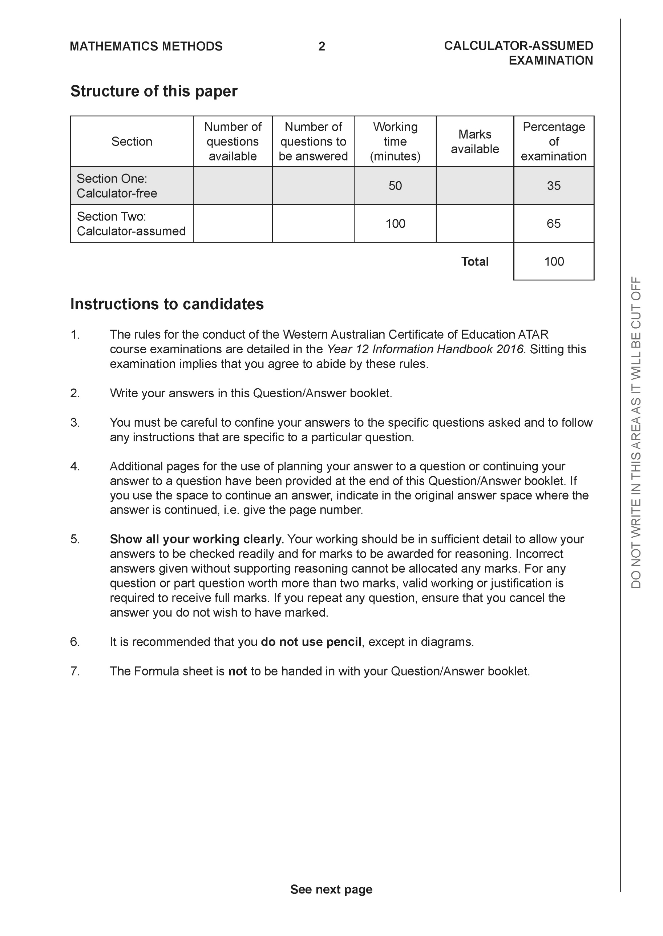

Section Two: Calculator-assumed (97 Marks)

This section has 11 questions. Answer all questions. Write your answers in the spaces provided.
Spare pages are included at the end of this booklet. They can be used for planning your responses and/or as additional space if required to continue an answer.
● Planning: If you use the spare pages for planning, indicate this clearly at the top of the page.
● Continuing an answer: If you need to use the space to continue an answer, indicate in the original answer space where the answer is continued, i.e. give the page number. Fill in the number of the question that you are continuing to answer at the top of the page.
Working time: 100 minutes.

Question 9 (6 marks)

Consider a ship moving towards the shore at 5m/s with a revolving light on the roof rotating
at10 rads/sec. This light causes a dot of light to move along the wall on the shore. Determine
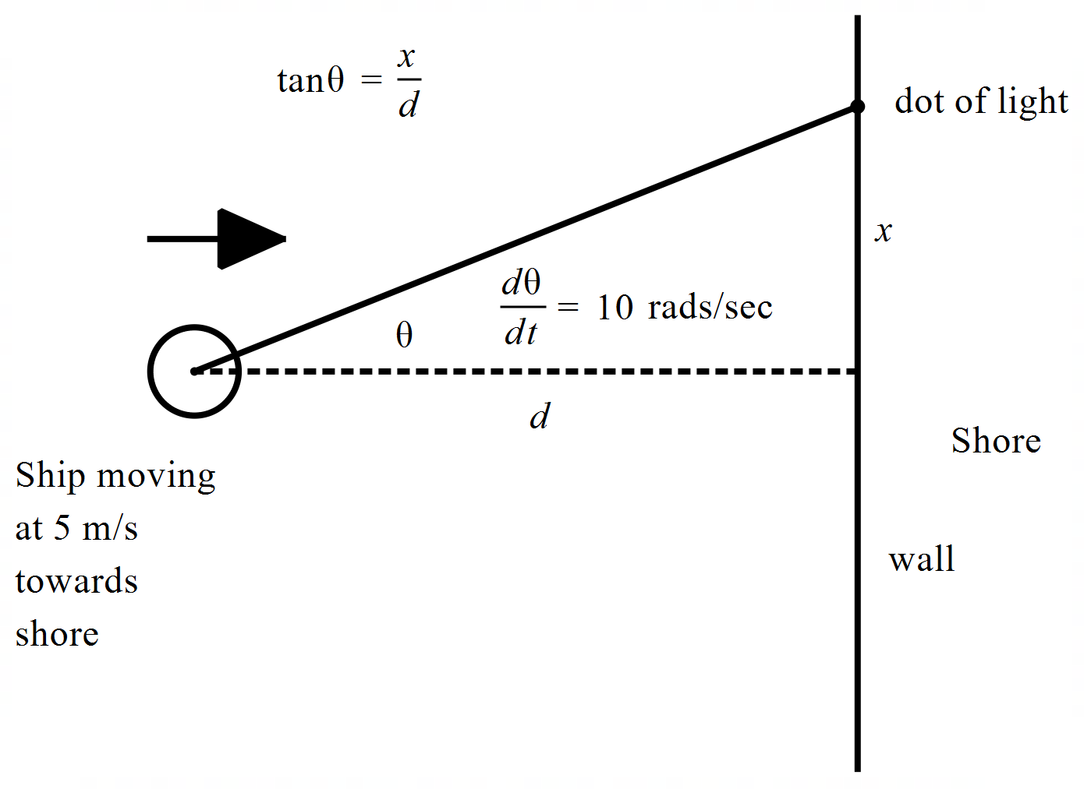the speed of the dot when the ship is 50 m from shore, m and the dot of light 3
metres from point directly opposite ship on shore, m. Answer to 2 decimal places in
m/s.

Question 10 (8 marks)

- On the axes below, sketch the slope field for (3 marks)
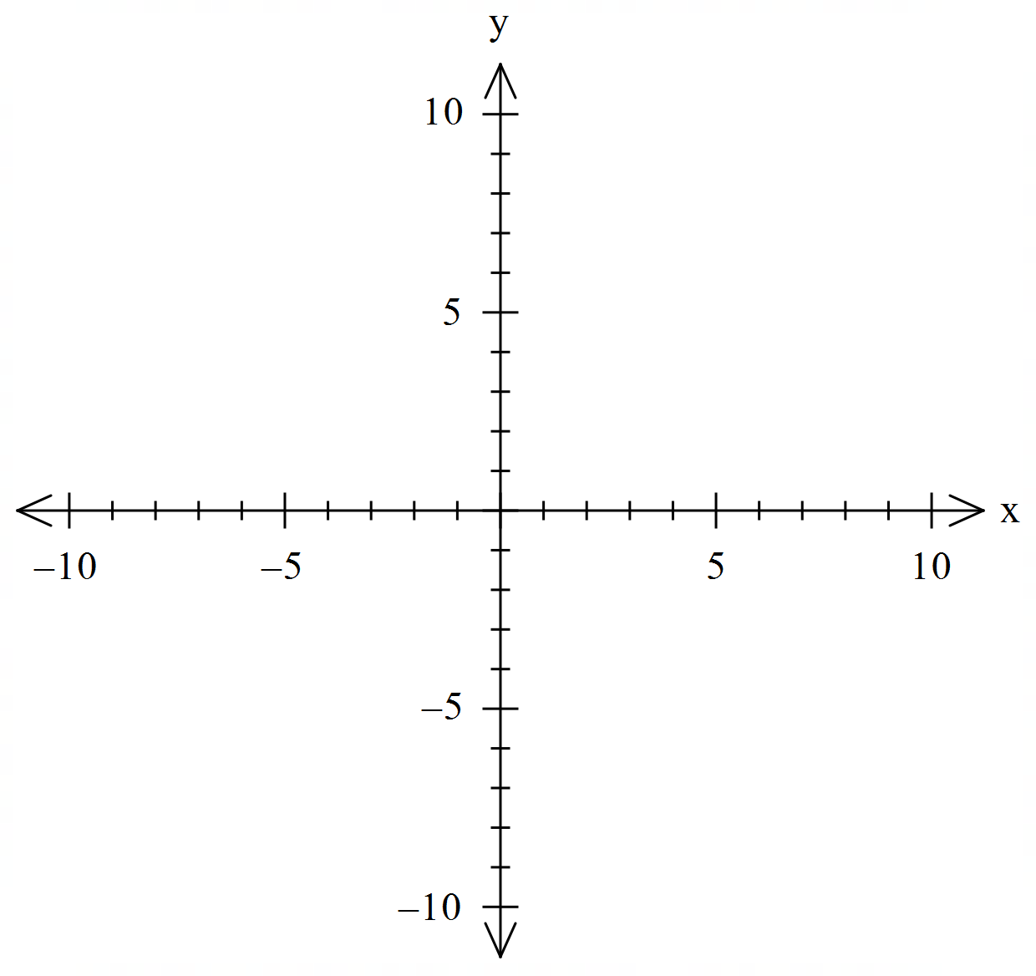

- On the axes above, sketch the solution curve that passes through the point (6,2)
(2 marks)

- Determine the Cartesian equation of the curve for part (b) above. (3 marks)

Question 11 (8 marks)

Consider the point A , plotted on the Argand plane below.

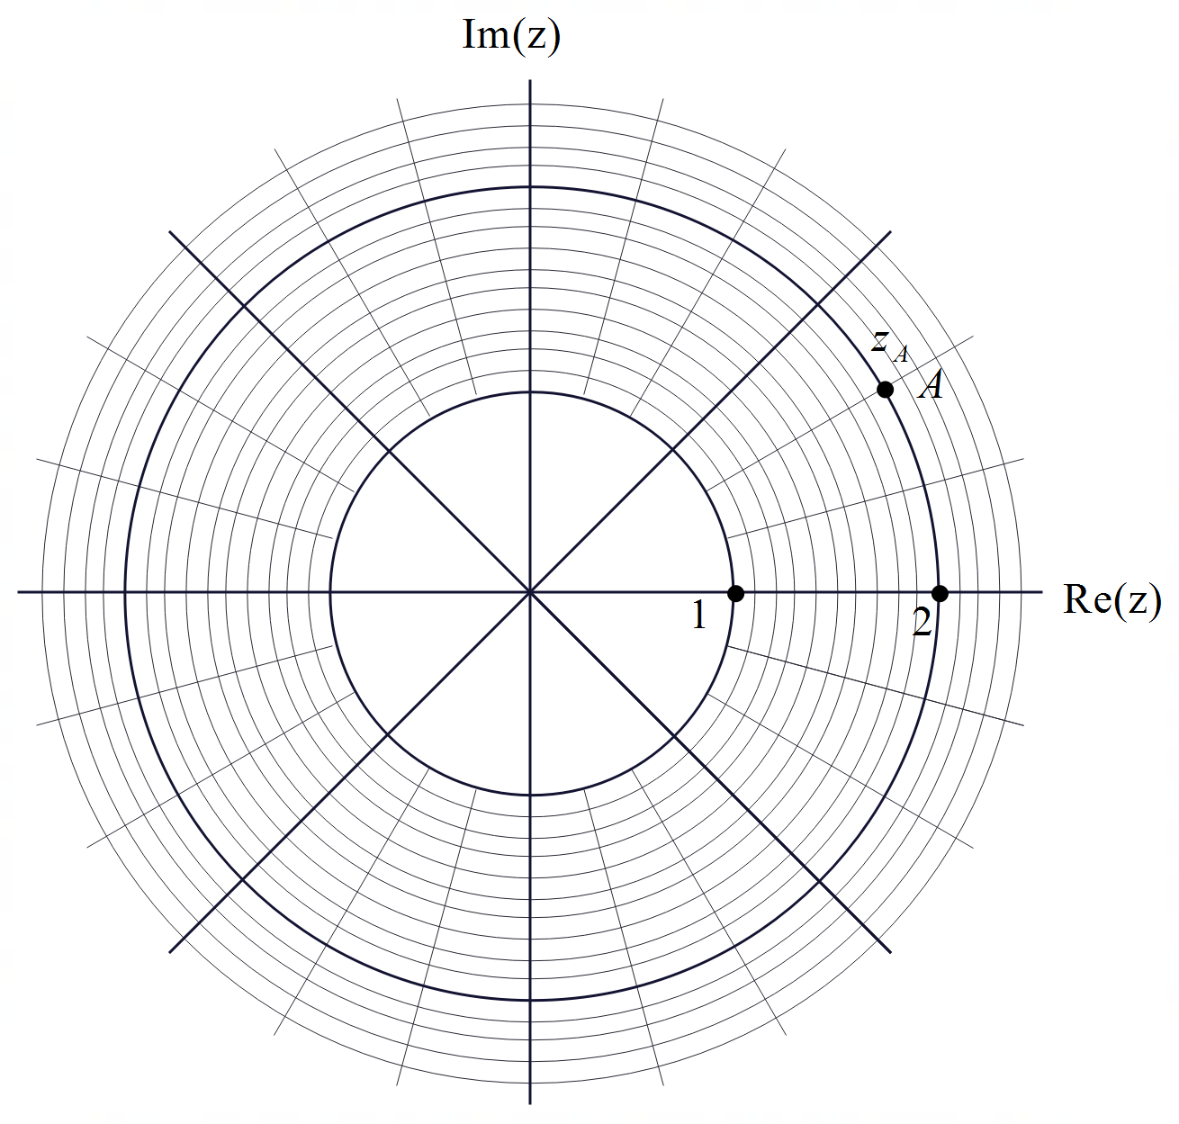

- Determine the polar form of point A, (2 marks)

- Plot the following value on the diagram above (3 marks)

- Shade the following region on the axes above:

(3 marks)

Question 12 (10 marks)

An object is moving along a straight line such that where , metres is the displacement from the origin. The maximum speed and the initial speed are both m/s.

- Determine an expression for at time seconds. (2 marks)

- Determine the percentage of time in the long run that the object is no more than 2 metres from the origin. (4 marks)

- Determine the speed and acceleration when the object is 1.5 metres from the origin.
(4 marks)

Question 13 (5 marks)

Consider a solid sphere of radius 9 metres with a cross-section as shown below.
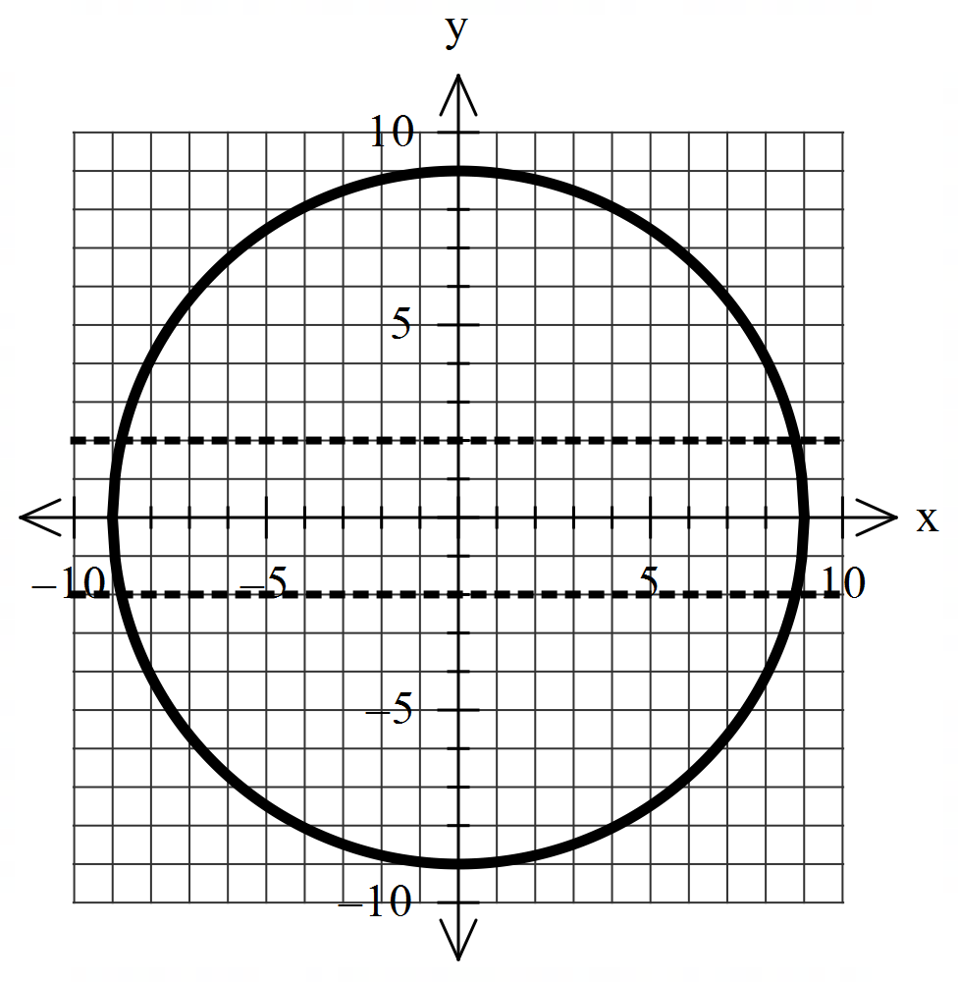

If a hollow cylinder of radius 2 metres, is drilled completely through the middle of the solid sphere, determine the volume of the sphere remaining.

Question 14 (9 marks)

- Solve the following system of equations showing full working. (3 marks)

- Determine all possible values of such the below system has: (3 marks)

- Unique solution
- Infinite solutions
- No solutions

Q14 continued

- For the values of that give infinite solutions in (bii) above, determine the vector equation of the line of possible solutions. (3 marks)

Question 15 (11 marks)

It is found that for the entire population of Yr 12 students in Australia that the mean number for daily homework is 2.5 hours with a standard deviation of 1.6 hours. Samples of 80 students are taken and the students sampled are surveyed as to their daily homework hours.

- Determine the probability that the mean number of homework hours in a sample is between 2 and 2.5 hours. (3 marks)

Let = sample mean of HW hours from samples of size 80 students.
- Define the probability distribution of . (2 marks)

- Sketch the probability density function for on the axes below. (2 marks)

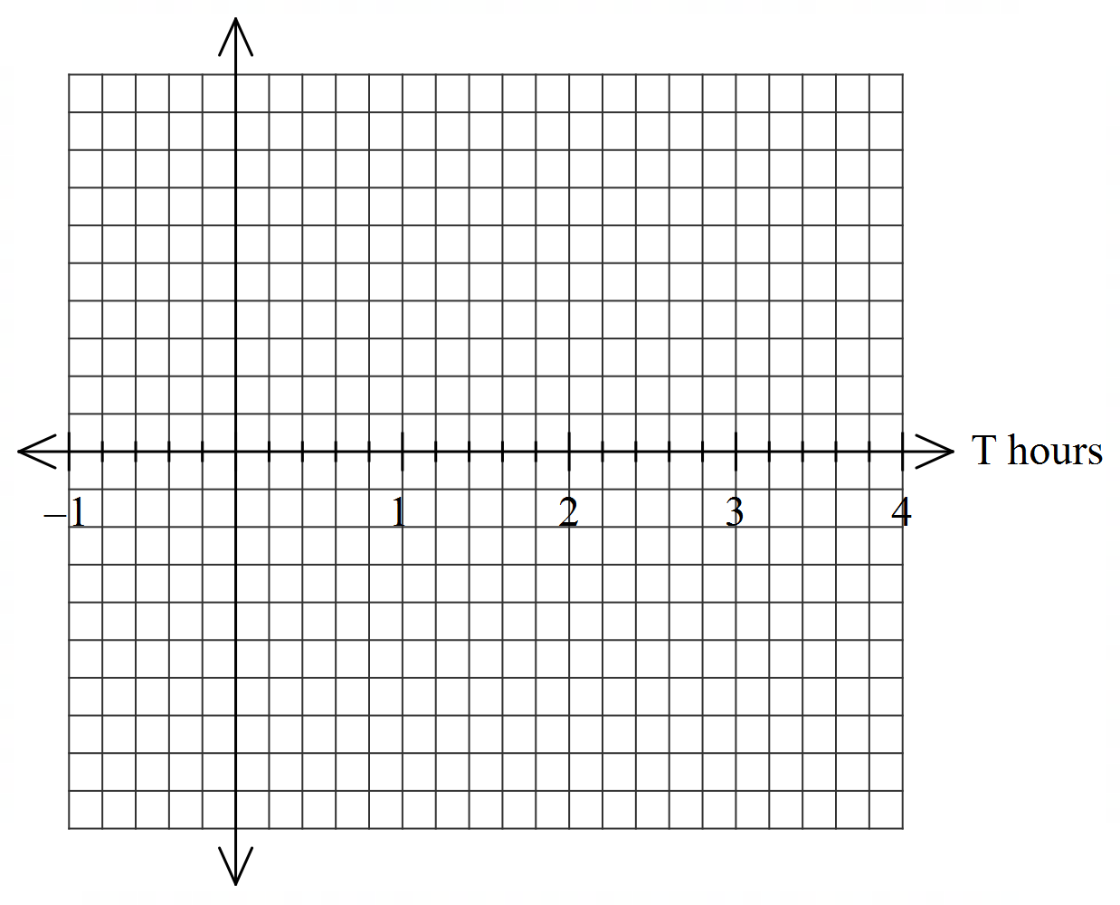

Q15 continued.
A sample of 100 Yr 12 students found that the mean number of HW hours is 2.0 hours with a sample standard deviation of 1.1 hours. It is suggested that it is highly likely that this sample is from the United Kingdom.

- Present an argument and necessary calculations to determine whether this suggestion is likely or not.
(4 marks)

Question 16 (11 marks)

Consider the triangle as with and as the origin.

- Show that is an isosceles triangle. (3 marks)

- Show that lies in the plane . (3 marks)

- Given that show that the line is perpendicular to the plane .
(2 marks)

- Given , determine the distance of pt to the plane containing .
(3 marks)

Question 17 (12 marks)

In order to estimate the mean amount of superannuation for workers in Perth, , a sample of workers were chosen with a sample mean of $90 000 and a sample standard deviation of and a 90% confidence interval width of $30 000.

- State the 90% confidence interval. (1 mark)

- Determine the sample mean standard deviation. (2 marks)

- In terms of , what sample size would give a 90% confidence interval of width of
$10 000? (3 marks)

- What is the probability to 3 decimal places that another sample size of 3 would give a sample mean that differs from by no more than $15 000? (3 marks)

- In each of the scenarios below, state whether the confidence interval width would increase or decrease. (3 marks)
- Sample size tripled.

- Confidence changed to 95%.

- Sample standard deviation decreased.

Question 18 (8 marks)

An ellipse has equation .(Note:) The tangent at a point with , intersects the x and y axes at Points respectively. The origin is at .

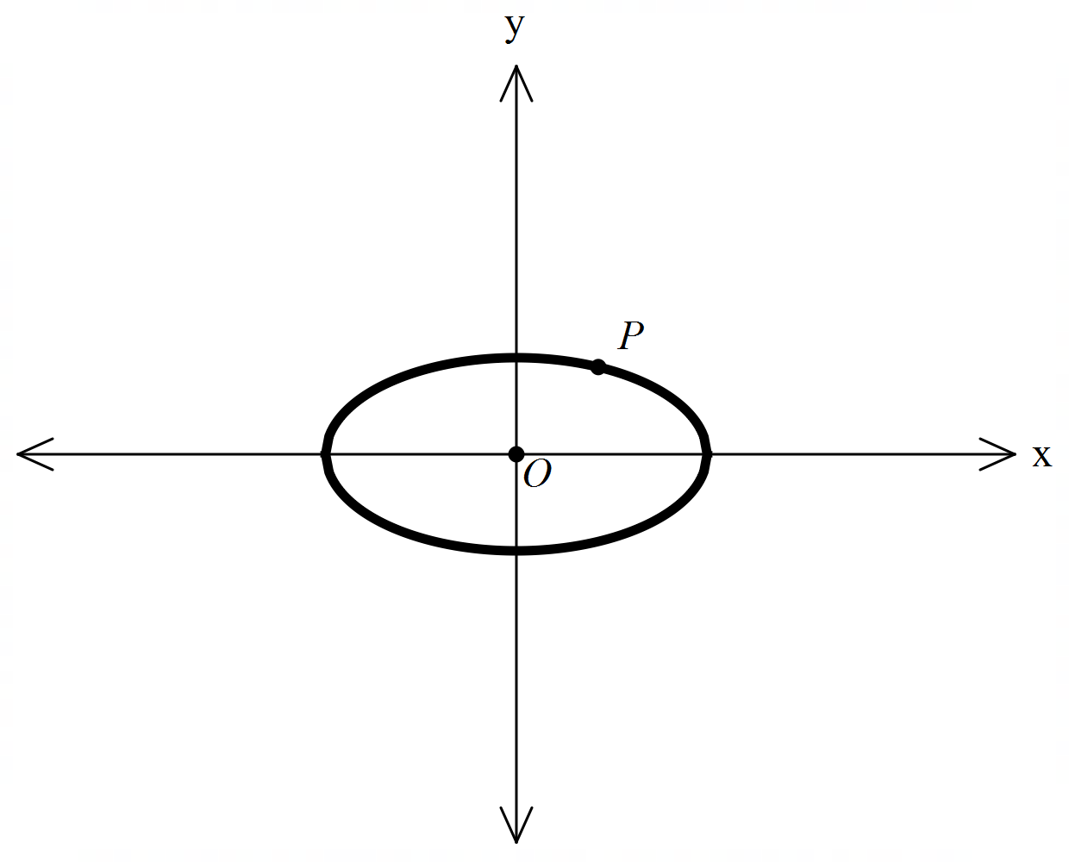

- Determine the area of triangle in terms of . (4 marks)
Note: Diagram is not drawn to scale.

Q18 continued.

- Determine the values of for which the area of triangle is a minimum and state this minimum area in terms of . (4 marks)

Question 19 (9 marks)

Consider a train that suddenly brakes causing a deceleration of metres per second squared, where equals its velocity and is the time in seconds from when the brakes are first applied. (Note:)

- Show that , where is the distance travelled from when the brakes are first applied. (3 marks)

- If is the velocity of the train when the brakes are first applied, show that the train comes to rest when . (3 marks)

- Show that the train stops when (3 marks)
(Hint- use the substitution )

